LABORATORIYA ISHI №4
Mavzu: PHP orqali MySQL ma’lumotlar bazasiga ulanish

1. Ishning maqsadi
- Tayyor MySQL bazaga PHP orqali ulanish
- SELECT so‘rovlarini bajarish
- INNER JOIN orqali bir nechta jadval ma’lumotlarini chiqarish
- MySQLi (procedural, OOP) va PDO usullarini taqqoslash
- Ular orasidagi farqlarni amaliy ko‘rsatish

2. Nazariy qism
PHP orqali MySQL bilan ishlashning 3 asosiy usuli mavjud:
- MySQLi (Procedural)
- MySQLi (Object-Oriented)
- PDO (PHP Data Objects)


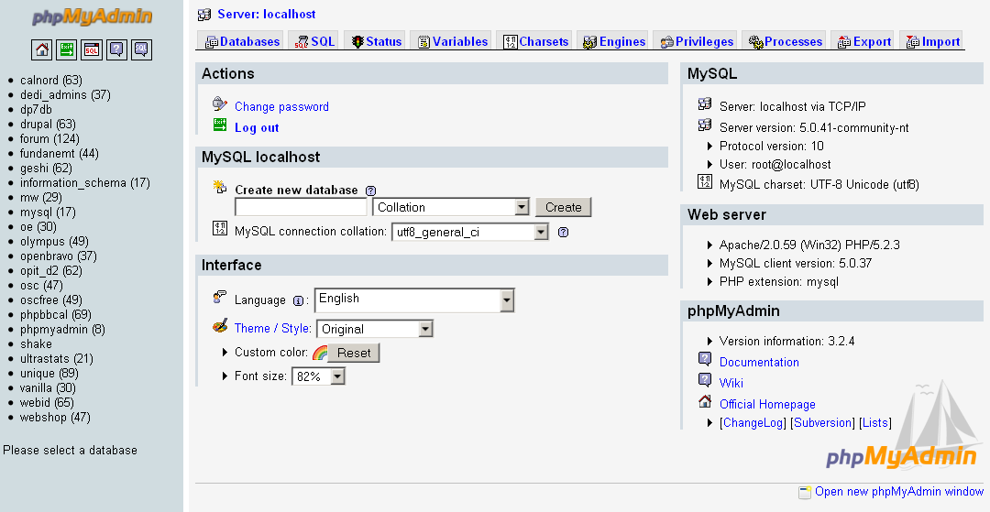

3. Amaliy baza (tayyor database)
Database: db_universitet
3 ta jadval:
fakultetlar
- id (PK)
- nomi
talabalar
- id (PK)
- ism
- kurs
- fakultet_id (FK)
fanlar
- id (PK)
- fan_nomi
- kredit
- talaba_id (FK)

4. Oddiy SELECT so‘rovi
SELECT * FROM talabalar;

5. JOIN so‘rovi
SELECT
talabalar.ism,
talabalar.kurs,
fakultetlar.nomi AS fakultet,
fanlar.fan_nomi
FROM talabalar
INNER JOIN fakultetlar ON talabalar.fakultet_id = fakultetlar.id
INNER JOIN fanlar ON talabalar.id = fanlar.talaba_id;

6. PHP orqali ulanish usullari
6.1 MySQLi – Procedural usul
<?php
$conn = mysqli_connect("localhost", "root", "", "db_universitet");
if (!$conn) {
die("Ulanish xatoligi: " . mysqli_connect_error());
}
$sql = "SELECT * FROM talabalar";
$result = mysqli_query($conn, $sql);
while ($row = mysqli_fetch_assoc($result)) {
echo $row['ism'] . " - " . $row['kurs'] . "<br>";
}
mysqli_close($conn);
?>
Xususiyatlari:
- Oddiy
- Faqat MySQL bilan ishlaydi
- Xavfsizlik PDO ga qaraganda pastroq
6.2 MySQLi – Object Oriented usul
<?php
$conn = new mysqli("localhost", "root", "", "db_universitet");
if ($conn->connect_error) {
die("Xatolik: " . $conn->connect_error);
}
$sql = "SELECT * FROM talabalar";
$result = $conn->query($sql);
while ($row = $result->fetch_assoc()) {
echo $row['ism'] . "<br>";
}
$conn->close();
?>
Xususiyatlari:
- OOP yondashuv
- Professionalroq
- Katta loyihalar uchun qulay
6.3 PDO usuli (Tavsiya etiladi)
<?php
try {
$conn = new PDO("mysql:host=localhost;dbname=db_universitet", "root", "");
$conn->setAttribute(PDO::ATTR_ERRMODE, PDO::ERRMODE_EXCEPTION);
$sql = "SELECT * FROM talabalar";
$stmt = $conn->query($sql);
while ($row = $stmt->fetch(PDO::FETCH_ASSOC)) {
echo $row['ism'] . "<br>";
}
} catch(PDOException $e) {
echo "Xatolik: " . $e->getMessage();
}
?>
Xususiyatlari:
- Turli DB lar bilan ishlaydi (MySQL, PostgreSQL, Oracle)
- Eng xavfsiz
- Prepared Statement kuchli
- try-catch bilan ishlaydi

7. PDO orqali JOIN misoli
<?php
try {
$conn = new PDO("mysql:host=localhost;dbname=db_universitet", "root", "");
$conn->setAttribute(PDO::ATTR_ERRMODE, PDO::ERRMODE_EXCEPTION);
$sql = "SELECT
talabalar.ism,
talabalar.kurs,
fakultetlar.nomi AS fakultet,
fanlar.fan_nomi
FROM talabalar
INNER JOIN fakultetlar
ON talabalar.fakultet_id = fakultetlar.id
INNER JOIN fanlar
ON talabalar.id = fanlar.talaba_id";
$stmt = $conn->query($sql);
echo "<table border='1'>";
echo "<tr><th>Ism</th><th>Kurs</th><th>Fakultet</th><th>Fan</th></tr>";
while ($row = $stmt->fetch(PDO::FETCH_ASSOC)) {
echo "<tr>
<td>{$row['ism']}</td>
<td>{$row['kurs']}</td>
<td>{$row['fakultet']}</td>
<td>{$row['fan_nomi']}</td>
</tr>";
}
echo "</table>";
} catch(PDOException $e) {
echo "Xatolik: " . $e->getMessage();
}
?>

8. Usullarni taqqoslash
Xususiyat | MySQLi Procedural | MySQLi OOP | PDO
DB turi | Faqat MySQL | Faqat MySQL | Ko‘p DB
Xavfsizlik | O‘rtacha | Yaxshi | Eng yaxshi
try-catch | Yo‘q | Yo‘q | Bor
Prepared | Bor | Bor | Juda kuchli
Professional | O‘rtacha | Yaxshi | Eng yaxshi

9. Natija
Laboratoriya ishida:
- Tayyor MySQL bazaga ulanish amalga oshirildi
- SELECT so‘rovi bajarildi
- INNER JOIN ishlatildi
- 3 xil PHP usuli taqqoslandi
- PDO eng tavsiya etiladigan usul ekanligi ko‘rsatildi
Topshiriqlar:

1-Universitet tizimi

<?php

$host = "localhost";

$dbname = "db_universitet";

$username = "root";

$password = "";

try {

$conn = new PDO("mysql:host=$host;dbname=$dbname;charset=utf8", $username, $password);

$conn->setAttribute(PDO::ATTR_ERRMODE, PDO::ERRMODE_EXCEPTION);

$sql = "

SELECT

talabalar.ism,

talabalar.kurs,

fakultetlar.nomi AS fakultet_nomi,

fanlar.fan_nomi,

fanlar.kredit

FROM talabalar

INNER JOIN fakultetlar ON talabalar.fakultet_id = fakultetlar.id

INNER JOIN fanlar ON fanlar.talaba_id = talabalar.id

";

$stmt = $conn->prepare($sql);

$stmt->execute();

$results = $stmt->fetchAll(PDO::FETCH_ASSOC);

} catch (PDOException $e) {

die("<h2 style='color:red;text-align:center;'>Xatolik: " . $e->getMessage() . "</h2>");

}

?>

<!DOCTYPE html>

<html>

<head>

<meta charset="UTF-8">

<title>Universitet tizimi</title>

<style>

body {

margin: 0;

padding: 0;

font-family: Arial, sans-serif;

background: linear-gradient(135deg, #4e73df, #1cc88a);

}

.container {

width: 90%;

max-width: 1100px;

margin: 50px auto;

background: white;

padding: 30px;

border-radius: 15px;

box-shadow: 0 15px 35px rgba(0,0,0,0.2);

}

h2 {

text-align: center;

color: #333;

margin-bottom: 25px;

}

table {

width: 100%;

border-collapse: collapse;

overflow: hidden;

border-radius: 10px;

}

th {

background-color: #4e73df;

color: white;

padding: 12px;

}

td {

padding: 10px;

text-align: center;

}

tr:nth-child(even) {

background-color: #f8f9fc;

}

tr:hover {

background-color: #d1ecf1;

transition: 0.3s;

cursor: pointer;

}

.footer {

text-align: center;

margin-top: 20px;

color: #777;

font-size: 14px;

}

@media (max-width: 768px) {

table, thead, tbody, th, td, tr {

display: block;

}

th {

display: none;

}

td {

padding: 10px;

border-bottom: 1px solid #ddd;

}

tr {

margin-bottom: 15px;

border: 1px solid #ccc;

border-radius: 10px;

padding: 10px;

}

}

</style>

</head>

<body>

<div class="container">

<h2>🎓 Universitet Talabalari Ro‘yxati</h2>

<table>

<tr>

<th>Ism</th>

<th>Kurs</th>

<th>Fakultet</th>

<th>Fan</th>

<th>Kredit</th>

</tr>

<?php foreach ($results as $row): ?>

<tr>

<td><?= htmlspecialchars($row['ism']) ?></td>

<td><?= htmlspecialchars($row['kurs']) ?></td>

<td><?= htmlspecialchars($row['fakultet_nomi']) ?></td>

<td><?= htmlspecialchars($row['fan_nomi']) ?></td>

<td><?= htmlspecialchars($row['kredit']) ?></td>

</tr>

<?php endforeach; ?>

</table>

<div class="footer">

© 2026 Universitet tizimi | PDO + INNER JOIN

</div>

</div>

</body>

</html>
Natija:
Saxifamning umumiy korinishi
